# 2014 Abingdon Youth Camp Journal

## INTRODUCTION

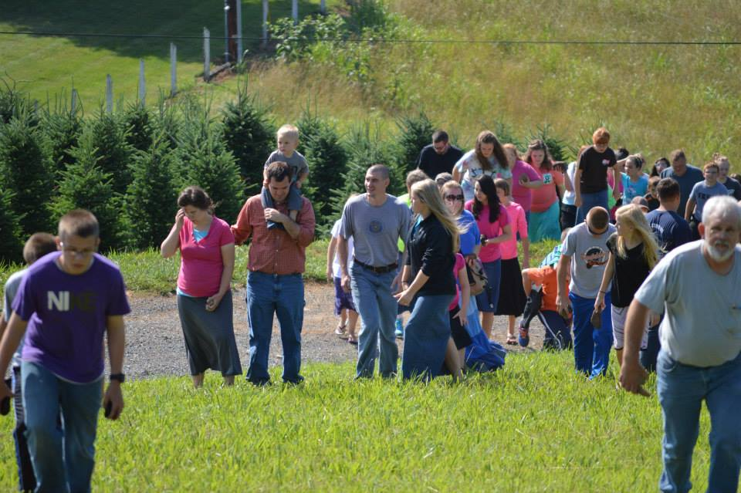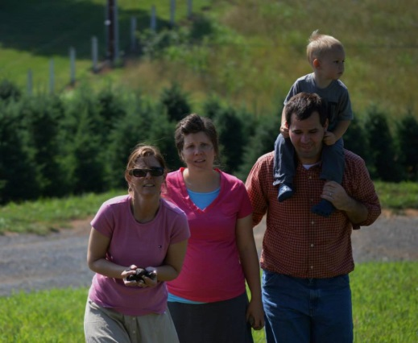

Pastor from Mississippi "I left a once in grace ASSOCIATION years ago. This is now my 'ASSOCIATION MEETING'!" [Had a special impact on MJD and took a liking to MJD.]

A Pastor's Post from NC "Our youth and older ones at Abingdon Va. Christian camp. June 25-30. The preaching is wonderful the spirit is so sweet. Thanking God for all the ones that gave their hearts to Christ. Many filled the altar every night. Thank you Lord for your sweet sweet spirit!!!"

Youth calling in after Camp - "This the Best camp we've ever had".

Pastor's Daughter - "Sister Laura was awesome. Her teaching changed my life."

## Traveling Down

**June 19 THU** - Left home, Spent the night with Lepages in Waynesboro, PA, Bro. Darel Holdsworth brought a feast (Jumbo-Jumbo shrimp, steaks, burgers, etc.) which was a wonderful surprise

**June 20 FRI** - Travelled 2 hrs. McGaheysville, VA and had a meeting with Bro. Powers about MJD's trip to Africa, travelled 6 more hours to Abingdon, VA and arrived about 11:30 pm (the pastor's family was waiting up for us), They were expecting us to arrive with a "TALL AFRICAN" (They called MJD the brother from Africa all week).

**June 21 SAT** - Helped with a few chores (14 prayer rocks, MJD painted them, it had been about 6 years), I went swimming in the river and MJD rested instead, "Annual before camp Cook Out" in the evening

**June 22 SUN** - **@AM** Bro. Corey Richards W. Jefferson, NC preached on "Not Being in the Number" 2 Corinthians 10:12, he is 27 yrs. old and has recently stepped down from pastoring. I skipped out of swimming in the river but MJD went with the brothers **@PM** SGR preached "Changes Before the Rain" Hosea 10:12; Acts 3:19 [struggled with my voice most the time, "breaking, sowing, seeking"] - Bro. Jason Nunley asked about how the Bible School was doing.

## Abingdon, VA Youth Camp

**June 23 MON** - **@AM** SGR preached "The Tender Plant" Isaiah 6:8-13; 53:1-3 [I had a good liberty to preach and my throat did not hinder.] **@PM** Bro. Damron "Taking Out the Trash" 2 Corinthians 5:17 [past sin that is covered and things already delivered from.] - SGR talked for 45 minutes with Mickey Neal, had given him a copy of "The Bride of Christ" during May @ Maryland Youth Camp, He shared several testimonies (both he and his wife have been struggling physically)

**June 24 TUE** - **@AM** Aaron Sizemore "Contrasting OT Life with a NT Experience" [He has been texting and emailing us ever since camp maybe 6 times with Bible Questions. He is eager for fellowshipping in the Word. "All that is God's is made available for the Believer through Christ" comment especially peaked his interest.] **@PM** Bro. Mike Dye "Not Everything that Glitters is Gold" [But God has the real Gold!]

**June 25 WED** - **@AM** Coty Parret "There is a Deliverance from Your Struggle" Jeremiah 2:13 -- Talked with a couple preachers for over an hour and they inquired about bible study materials that they could take through correspondence -- There was some conflict in the camp threatening the unity, but God brought us through it "We are family" **@PM** LRR led the Choir in "I Hear the Chains Falling" -- Isaiah Haney Testified, not a dry eye in the tent -- Jacob Berry preached "The Gift" [simple but profound salvation message] John 3:16

**June 26 THUR** - **@AM** LRR took all the girls into the church and SGR took all the boys under the tent. Both taught on purity to the young people and received overwhelming responses especially with the young ladies. girls "We Are Royalty" 1 Peter 2:9 - boys "Becoming the ONE Versus Finding the ONE" Titus 1:15; Matthew 6:21-23 **@PM** LRR led the Choir in "I Hear the Chains Falling" -- Jacob Berry preached "The Center of God's Hand" [versus his finger tips, illustrated by a penny in his hand] Deut. 32:35

**June 27 FRI** - **@AM** 4 skits led by preachers and preacher's wives (All were excellent skits on the theme "We are Royalty") - ladies of camp gave LRR a surprise baby shower and were very generous with gifts and kindness **@PM** LRR had taught the choir "Come Bless the Lord All You Servants of the Lord" and led them in singing it- Jacob Berry preached "God Has Been Good to You" [Had each camper 1 at a time stand before him and look at him and then look at a mirror of themself.] Children prayed, marched around the TENT, cried and worshipped for well over an hour. Prayed the best of the whole week. Several Testimonies afterward were given: 16 year old girl said she had been in church in the whole time, but it had been years since she felt God!

We ate and played basketball until 3 am. 3 Young preachers showed special interest in our ministry of the Word. Brandon, Andrew, Jacob. We talked quit a while about the things of the Lord. They asked for preaching CD's. I gave a copy of DOCTRINE I notes to a Pastor who didn't attend the camp, but had called in.

## Returning Home

**June 28 SAT** - Left Abingdon, VA and drove to Joppa, Maryland (dropped MJD off at Bro. Andy Parret's home)

**June 29 SUN** - **@AM** URGT SGR preached "A New Way of Living" Romans 6:1-4 [If its sinful get rid of it, if is temporal use moderation, if its Godly Get all you can!] -- MJD preached at Dogwood Church both AM & PM **@PM** Sis. Snyder preached on "Get Rid of the Weeds in Your Garden" Mark 4:19

**June 30 MON** - visited with family and visited Bro. Perry Grose at Hospital - Supreme Court Rules in Favor of Hobby Lobby's Right not to pay for morning after pills for Employees (on the grounds of religious conviction). [July 5, 60 protesters gathered at Hobby Lobby in Tulsa "Your Religous belief's are not welcome in my bedroom", "They (Supreme Court) have utterly failed the country yet again.","If women do not protest, we're going to be barefoot and pregnant in the 21st Century"] THERE IS A CAUSE!

**July 1 TUE** - rested, studied and visited with family -- URGT Bro. Grose Gave Message and Exhorted (An Urgent Invitation) - SGR was scheduled to preach and leave for home WED morning, but we felt to stay one more night and help Bro. Daniel Hooker and his church.

**July 2 WED** - Bro. Hooker's Church SGR preached "God's Enemies" [The world its people and its system] James 4:4; Exodus 4:24 (Asking for revival, fellowship) God really helped LRR -- MJD preached at Dogwood

**July 4 FRI** - 3 am arrived home, 1:30 am (13 hrs; thought we broke down); Arrived home to an undisturbed bedroom -- PRAISE THE LORD! -- ISIS terrorists “I tell you, Spain is the land of our forefathers, and, Allah willing, we are going to liberate it, with the might of Allah,” says one of the men. He adds that the group won’t stop at Spain and intends to spread its Islamic Caliphate across the world.

## Prayer Requests:

* Baby at Youth Camp
* Isaiah Haney and His Family
* Laura's Mom
* Perry Grose
* Bro. Hooker's children 1) Sarah and 2) his son
* Bro. Corey Richardson
* Coming Youth Camp and Our Youth
* Tent Revival August 8-17 @ Rockland, Maine -- August 22-31 @ Falmouth, Maine
* Deliverance Bible Institute
* August 10 - FGBI Student Pre-Mission trip Report